Install Power BI Desktop

To download Power BI Desktop go Microsoft’s official download site. This is the link to directly download Power BI files −

<https://www.microsoft.com/en-us/download/details.aspx?id=45331>

select a language in which they want to install Power BI and following files are available for download.

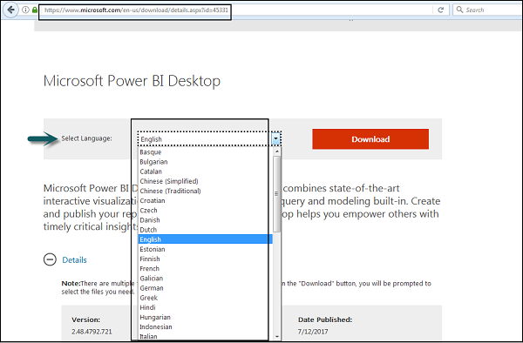

When you run the installation file, following screen is displayed.

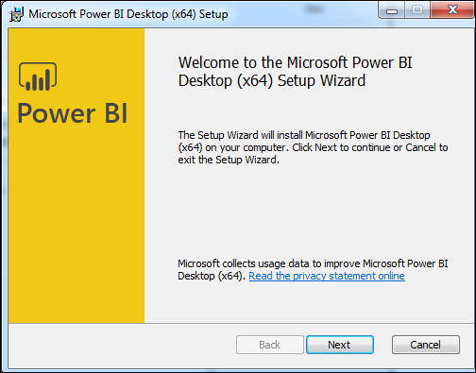

Accept the license agreement and follow the instructions on the screen to finish the installation.

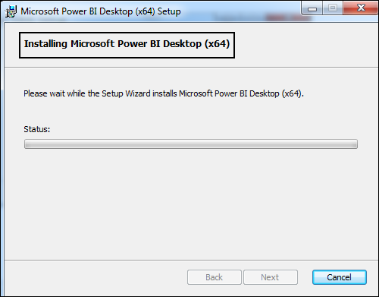

When Power BI is installed, it launches a welcome screen. This screen is used to launch different options related to get data, enrich the existing data models, create reports as well as publish and share reports

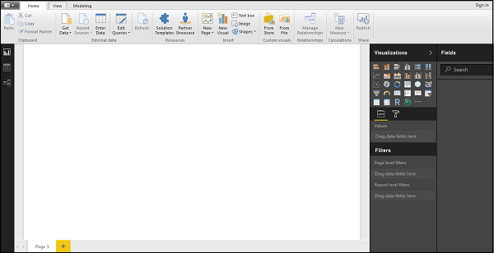

**Report View:** Power BI Desktop includes a Report view, where you can create any number of report pages with visualizations. Report view in Power BI Desktop provides a similar design experience to the report's editing view in the Power BI service. You can move visualizations around, copy and paste, merge, and so on.

When you first load data in Power BI Desktop, we could see the Report view with a blank canvas.

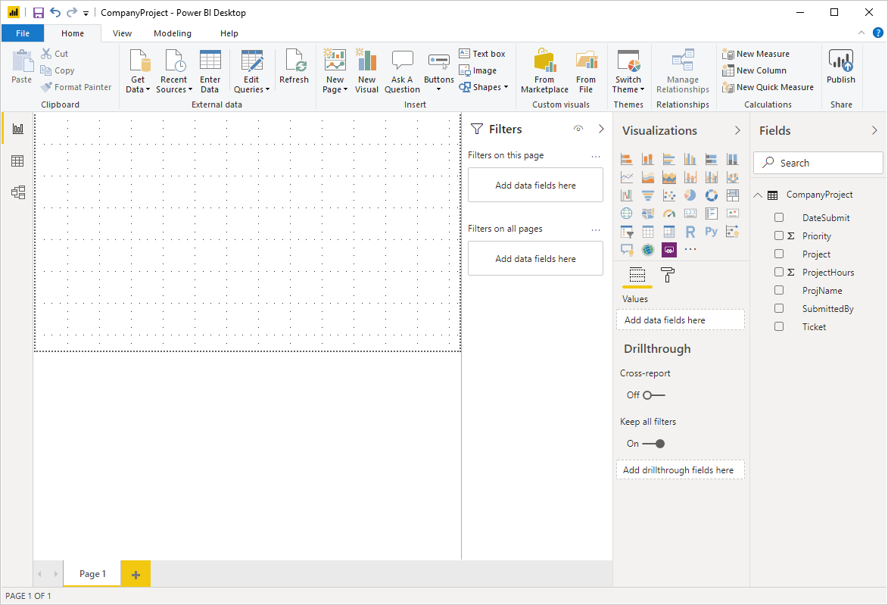

We can switch between **Report**, **Data**, and **Relationship** views by selecting the icons in the left-hand navigation pane:

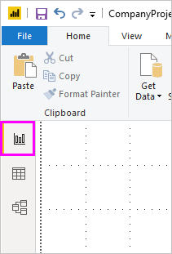

**Data view** helps you inspect, explore, and understand data in your Power BI Desktop model. It's different from how we view tables, columns, and data in Power Query Editor. With Data view, we were looking at data after it has been loaded into the model.

When we are modeling data, sometimes we want to see what's actually in a table or column without creating a visual on the report canvas. We might want to see right down to the row level. This ability is especially useful when we are creating measures and calculated columns, or need to identify a data type or data category.

Let's take a closer look at some of the elements found in Data view.

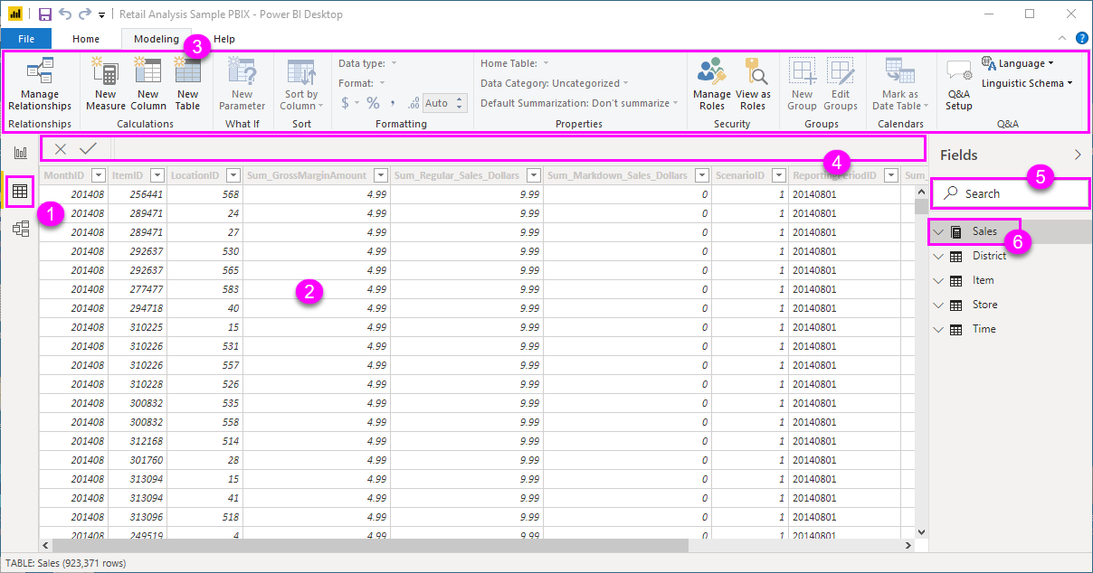

1. **Data view icon**. Select this icon to enter Data view.
2. **Data Grid**. This area shows the selected table and all columns and rows in it. Columns hidden from *Report* view are greyed out. You can right-click on a column for options.
3. **Modeling ribbon**. Here you can manage relationships, create calculations, change data type, format, data category for a column.
4. **Formula bar**. Enter Data Analysis Expression (DAX) formulas for Measures and Calculated columns.
5. **Search**. Search for a table or column in your model.
6. **Fields list**. Select a table or column to view in the data grid.

***Model view*** shows all of the tables, columns, and relationships in our model. This view can be especially helpful when your model has complex relationships between many tables.

Select the **Model** icon near the side of the window to see a view of the existing model. Hover your cursor over a relationship line to show the columns that are used.

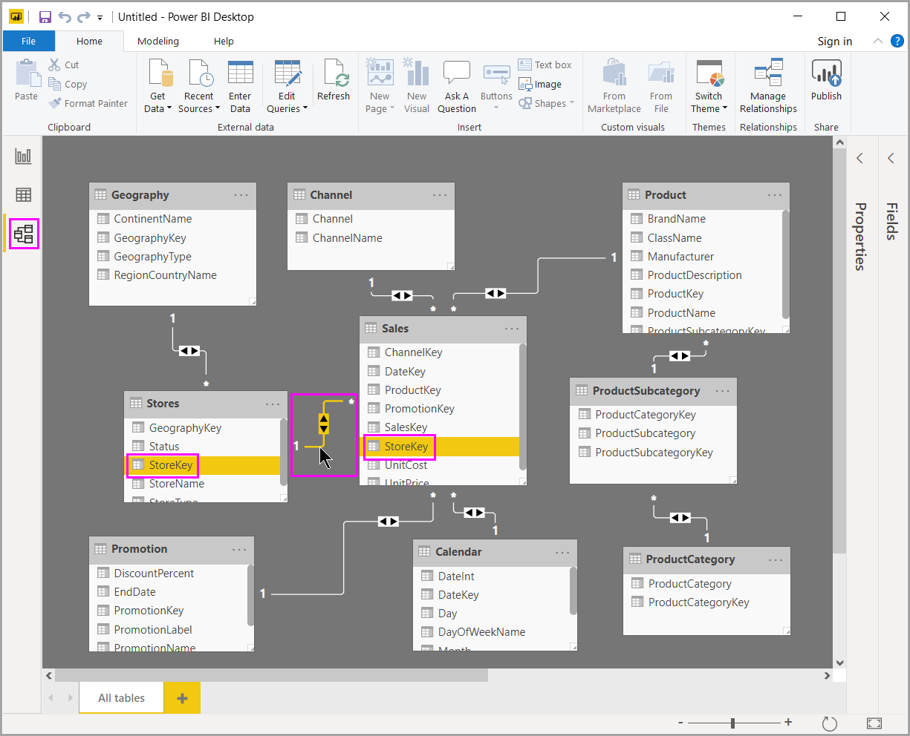

Power Query Editor

Power BI Desktop also comes with Power Query Editor. Use Power Query Editor to connect to one or many data sources, shape and transform the data to meet your needs, then load that model into Power BI Desktop.

To get to Power Query Editor, select **Edit Queries** from the **Home** tab of Power BI Desktop.

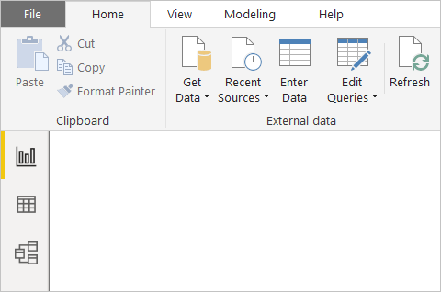

With no data connections, Power Query Editor appears as a blank pane, ready for data.

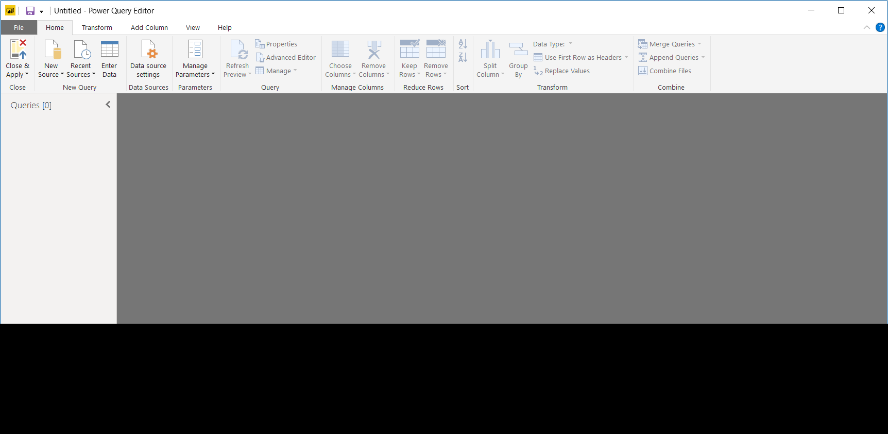

The ribbon in Power Query Editor consists of four tabs: **Home**, **Transform**, **Add Column**, and **View**.

The **Home** tab contains the common query tasks.

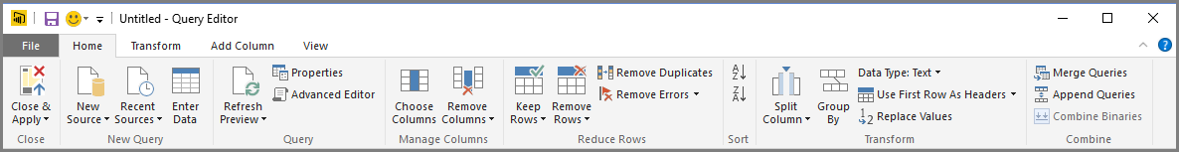

To connect to data and begin the query building process, select **New Source**. A menu appears, providing the most common data sources.

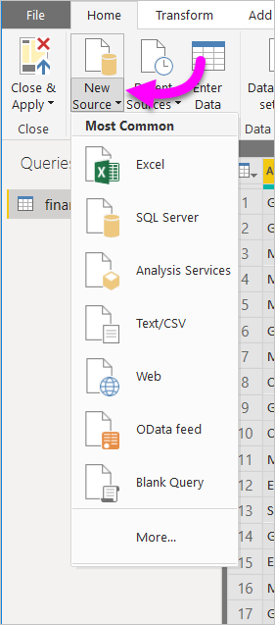

For more information about available data sources, see **Data Sources**. For information about connecting to data, including examples and steps, see **Connect to Data**.

The **Transform** tab provides access to common data transformation tasks, such as:

* Adding or removing columns
* Changing data types
* Splitting columns
* Other data-driven tasks

The **Add Column** tab provides additional tasks associated with adding a column, formatting column data, and adding custom columns. The following image shows the **Add Column** tab.

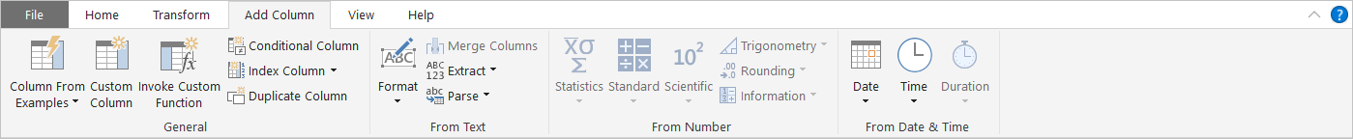

The **View** tab on the ribbon is used to toggle whether certain panes or windows are displayed. It’s also used to display the Advanced Editor. The following image shows the **View** tab.

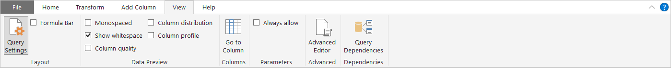

**Advanced Editor**

The **Advanced Editor** lets you see the code that Power Query Editor is creating with each step. It also lets you create your own shaping code. To launch the advanced editor, select **View** from the ribbon, then select **Advanced Editor**. A window appears, showing the existing query code.

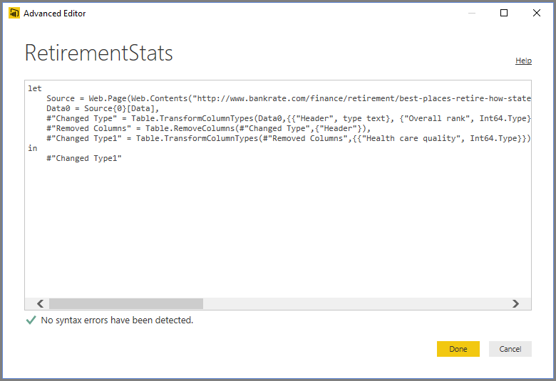

You can directly edit the code in the **Advanced Editor** window. To close the window, select the **Done** or **Cancel** button.

When it comes to self-service business analytics, Power BI is among the most popular options for businesses and individuals. Power BI has proven that it can enable users of all skill levels to get the most from their data.

There are three types of Power BI currently available – Desktop (Free), Pro and Premium.

If you are a small business or a one-man band you are probably switching between the Power BI Desktop and Pro versions.

**Power BI Desktop:**

Power BI Desktop is tailored for small business and individuals who want to get more insights from with data. Large scale collaboration and integration is not always necessary and if that sounds like you – Desktop is a very comprehensive solution.

Power BI Desktop is the free version of Power BI it’s included with all Office 365 plans plus you can sign up anytime you want here. Even though this is a free version it’s surprisingly functional – it allows you to connect to all the data sets that Pro allows, with no restriction on how much data you pull in, it also lets you clean, prepare and build your visualizations without restrictions.

**Best for:**

Companies without a business intelligence or data science budget.

Businesses with less data to analyze, possibly only a handful of data sets.

Small businesses and solo entrepreneurs.

**Power BI Pro:**

Power BI Pro is the full, licensed based version, which means it comes with complete capability for building dashboards, reporting and importantly sharing reports (which is not available on desktop). Power BI is for businesses that require many users to have the capability to create and share reports.

The Pro license has all the features of the desktop version and comes as part of the Office 365 Enterprise E5 license.

**Best for:**

Medium and large-scale business.

Corporations with big data and data scientists.

Multi-location businesses.

**Power BI Desktop vs Power BI Pro:**

Although functionality is very similar across the two packages, Power BI Pro allows users to share reports and dashboards with other users, as well as collaborate in private, across devices and applications. This functionality is not possible for Power BI Desktop users, which only allows you to share dashboards publicly on the web, which is not suitable for confidential information nor can you collaborate on your reports.

Both Power BI Desktop and Power BI Pro have the same data capacity limit of 10GB.

Both Power BI Desktop allow you to access via Mobile devices.

Both Power BI Desktop allow you to integrate with apps and content packs including Dynamics and Analytics.

Both Power BI and Desktop allow you to import from Excel, CSV and other applications.

Power BI Desktop does not allow you to publish your reports and dashboards to web privately.

Both Power BI Desktop have 8 data refreshes a day with a minimum of 30 minutes between each.

Power BI Desktop does not integrate with Office 365 applications so reports cannot be exported to CSV or PPTX.

Power BI Desktop does not allow you to view reports and dashboards from Pro license users.

Power BI Desktop does not allow use Office 365 Groups in BI.

Power BI Desktop does not allow you to share reports with other BI users.

Power BI Desktop does not allow you to view reports and dashboards from Pro license users.

**Power BI Pro Vs Premium**

The functional difference between Power BI Pro and Premium are pretty small – they have many of the same capabilities; it really comes down to what is more economical for the scale of your business. Typically, Premium will only be cost effective for organizations with large deployments in terms of storage usage or hundreds of users.

Although the functional elements are very similar, there are some differences – Power BI Premium license is not a per-user price point, like the Free and Pro solutions. Instead the Premium license is a dedicated capacity for the entire organization, large datasets of up to 50GB in size can be processed and total of 100TB of data storage with a maximum number of 48 refreshes a day. Power BI Premium is an on-premise solution that can be moved to the cloud once the organization is ready.

**Best for:**

Large scale businesses with huge data sets.

Corporations with big data and data scientists.

They both possess 50GB Mailboxes, Custom Email addresses, 1TB of OneDrive, 24/7 Support, among other features.

**The product breakdown:**

